Fusion ERP — Placement Cell Management System (PCMS)
Workflow Specifications v1.3 — FINAL (DIRECT_FINAL_v2)
Final synchronization note: The authoritative behavioral form is the state-transition table. The validated topology remains 8 Basis Workflows and 4 Composite Workflows. Informational behavior and isolated actions are not forced into workflows. Company registration remains outside the workflow set because the institutional approval decision/actor is unresolved; announcement publication remains an isolated UC whose automated notification is represented by event-triggered PC-UC-007.

1. Legacy Workflow Disposition
Legacy WF | Disposition | Replacement | Reason
PC-WF-001 | Reconstructed | CW-PC-04 | Broad end-to-end concept retained as a composite, but steps now use concrete UCs and explicit states/guards.
PC-WF-002 | Retired | N/A | Company approval actor/process is external/unspecified, so the accepted baseline does not support a connected PCMS registration-approval progression without inventing a transition.
PC-WF-003 | Reconstructed | BW-PC-01/BW-PC-02/BW-PC-03; CW-PC-01 | Publication paths separated by TPO-managed, direct Company, and Company-submit-via-TPO outcomes.
PC-WF-004 | Reconstructed | BW-PC-01/BW-PC-02/BW-PC-03/BW-PC-04; CW-PC-01/CW-PC-02 | Application is a state-changing transition inside connected cross-actor placement progressions; it is not forced into an isolated standalone workflow.
PC-WF-005 | Reconstructed | BW-PC-04/BW-PC-05/BW-PC-06; CW-PC-02 | Company shortlisting is separated from TPO administrative review and from interview scheduling.
PC-WF-006 | Reconstructed | BW-PC-05/BW-PC-06; CW-PC-02 | TPO- and Company-led scheduling paths are explicit.
PC-WF-007 | Reconstructed | BW-PC-07/BW-PC-08; CW-PC-03 | Offer acceptance and rejection are separate basis paths with deadline and placement-update guards.
PC-WF-008 | Retired | N/A | Announcement publication is an isolated actor goal; its automated email side effect is represented by event-triggered PC-UC-007, not by a separate workflow.

2. Final Workflow Specifications

BW-PC-01: TPO-Published Opportunity to Student Application
Type | Basis
Purpose / Scope | One path from TPO-managed posting publication to an eligible Student application.
Trigger | TPO prepares a job posting for publication.
Participants | TPO, Student
Constituent Workflows | N/A
Related Workflows | N/A
Related CFRs / key AFRs
Related UCs | PC-UC-003, PC-UC-006
Related BRs | PC-BR-001, PC-BR-002, PC-BR-003, PC-BR-004, PC-BR-005
Notes | None
Authoritative State-Transition Table
S. No. | From State | Actor | Use Case ID / Name | Guard / Outcome | Resulting State | BR Reference(s)
1 | No published opportunity / managed draft | TPO | PC-UC-006 Upload and Manage Job Postings | Required posting content valid; TPO authorized; outcome = Publish | Opportunity Published | PC-BR-003, PC-BR-004, PC-BR-005
2 | Opportunity Published | Student | PC-UC-003 Apply for Eligible Job Posting | Profile completeness (if required) and eligibility satisfied | Application Applied | PC-BR-001, PC-BR-002
Corresponding workflow diagram
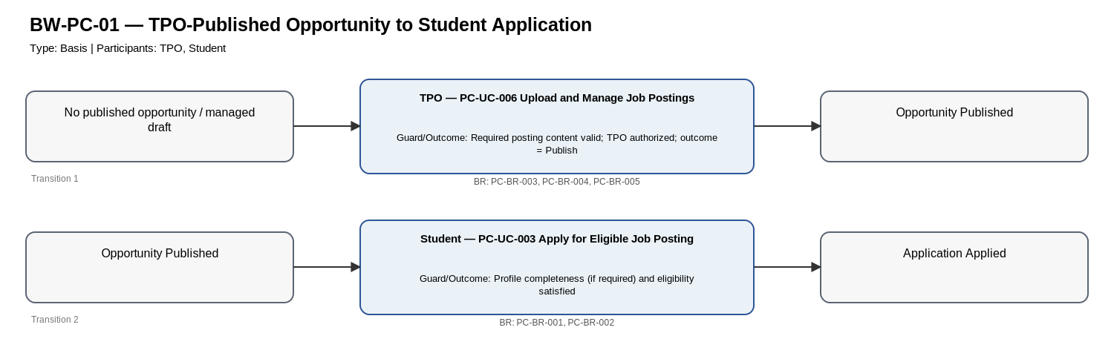
Editable source: Workflow_Diagrams/PC_Workflow_Diagrams_v1.2_SYNCHRONIZED.drawio (page BW-PC-01).

BW-PC-02: Company-Published Opportunity to Student Application
Type | Basis
Purpose / Scope | One path from direct Company/Recruiter publication to an eligible Student application.
Trigger | Authorized Company/Recruiter creates an opportunity and direct publication is permitted.
Participants | Company/Recruiter, Student
Constituent Workflows | N/A
Related Workflows | N/A
Related CFRs / key AFRs
Related UCs | PC-UC-003, PC-UC-015
Related BRs | PC-BR-001, PC-BR-002, PC-BR-003, PC-BR-004, PC-BR-006
Notes | None
Authoritative State-Transition Table
S. No. | From State | Actor | Use Case ID / Name | Guard / Outcome | Resulting State | BR Reference(s)
1 | No published opportunity | Company/Recruiter | PC-UC-015 Publish or Submit Company Opportunities and Define Eligibility | Company authorized; required content valid; outcome = Direct Publish | Opportunity Published | PC-BR-003, PC-BR-004, PC-BR-006
2 | Opportunity Published | Student | PC-UC-003 Apply for Eligible Job Posting | Profile completeness (if required) and eligibility satisfied | Application Applied | PC-BR-001, PC-BR-002
Corresponding workflow diagram
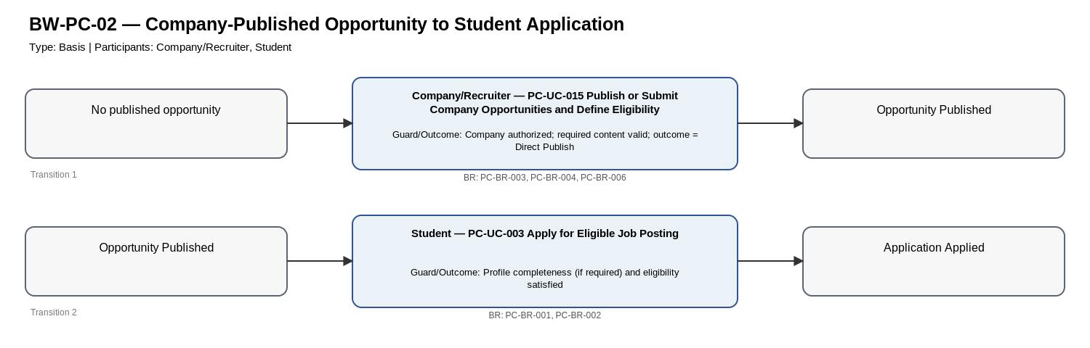
Editable source: Workflow_Diagrams/PC_Workflow_Diagrams_v1.2_SYNCHRONIZED.drawio (page BW-PC-02).

BW-PC-03: Company Submission via TPO to Student Application
Type | Basis
Purpose / Scope | One path where a Company/Recruiter submits an opportunity, TPO publishes/manages it, and an eligible Student applies.
Trigger | Authorized Company/Recruiter creates an opportunity and uses the submit-for-TPO path.
Participants | Company/Recruiter, TPO, Student
Constituent Workflows | N/A
Related Workflows | N/A
Related CFRs / key AFRs
Related UCs | PC-UC-003, PC-UC-006, PC-UC-015
Related BRs | PC-BR-001, PC-BR-002, PC-BR-003, PC-BR-004, PC-BR-005, PC-BR-006
Notes | None
Authoritative State-Transition Table
S. No. | From State | Actor | Use Case ID / Name | Guard / Outcome | Resulting State | BR Reference(s)
1 | No published opportunity | Company/Recruiter | PC-UC-015 Publish or Submit Company Opportunities and Define Eligibility | Company authorized; required content valid; outcome = Submit | Opportunity Submitted | PC-BR-003, PC-BR-004, PC-BR-006
2 | Opportunity Submitted | TPO | PC-UC-006 Upload and Manage Job Postings | TPO authorized; posting content valid; outcome = Publish | Opportunity Published | PC-BR-003, PC-BR-004, PC-BR-005
3 | Opportunity Published | Student | PC-UC-003 Apply for Eligible Job Posting | Profile completeness (if required) and eligibility satisfied | Application Applied | PC-BR-001, PC-BR-002
Corresponding workflow diagram
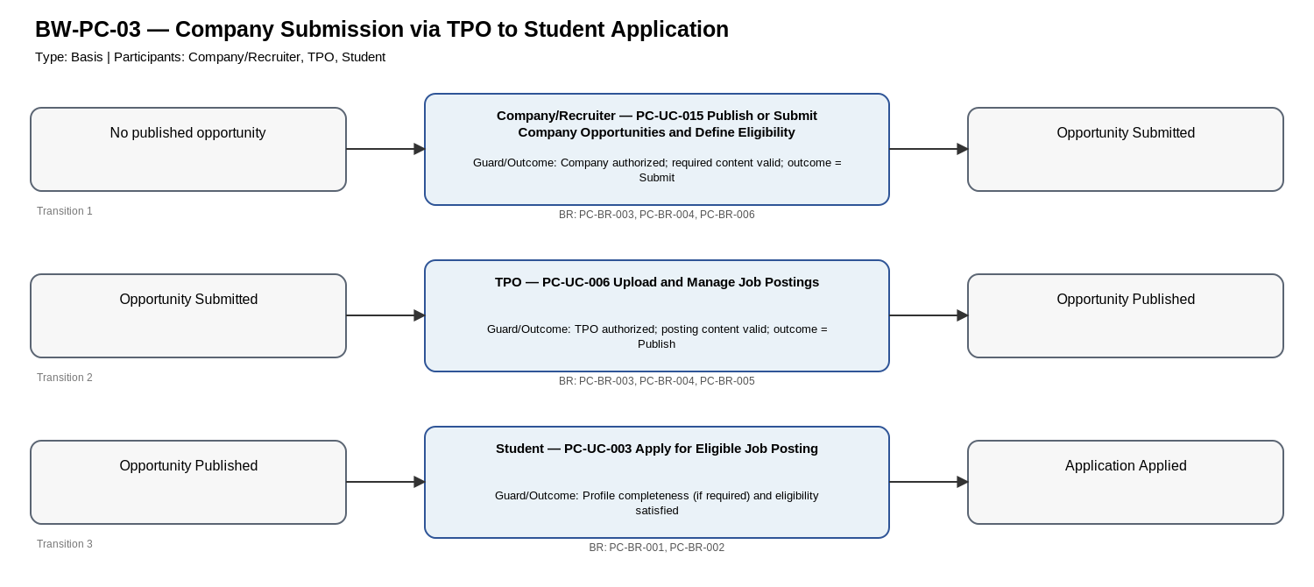
Editable source: Workflow_Diagrams/PC_Workflow_Diagrams_v1.2_SYNCHRONIZED.drawio (page BW-PC-03).

BW-PC-04: Application to Shortlist
Type | Basis
Purpose / Scope | One path from an eligible Student application to a recorded Company/Recruiter shortlist decision.
Trigger | Published opportunity is open to an eligible Student.
Participants | Student, Company/Recruiter
Constituent Workflows | N/A
Related Workflows | N/A
Related CFRs / key AFRs
Related UCs | PC-UC-003, PC-UC-016
Related BRs | PC-BR-001, PC-BR-002, PC-BR-009, PC-BR-030
Notes | None
Authoritative State-Transition Table
S. No. | From State | Actor | Use Case ID / Name | Guard / Outcome | Resulting State | BR Reference(s)
1 | Opportunity Published | Student | PC-UC-003 Apply for Eligible Job Posting | Profile completeness (if required) and eligibility satisfied | Application Applied | PC-BR-001, PC-BR-002
2 | Application Applied | Company/Recruiter | PC-UC-016 Review Applications and Record Shortlist/Rejection Update | Application belongs to Company opportunity; outcome = Shortlist | Application Shortlisted | PC-BR-009, PC-BR-030
Corresponding workflow diagram
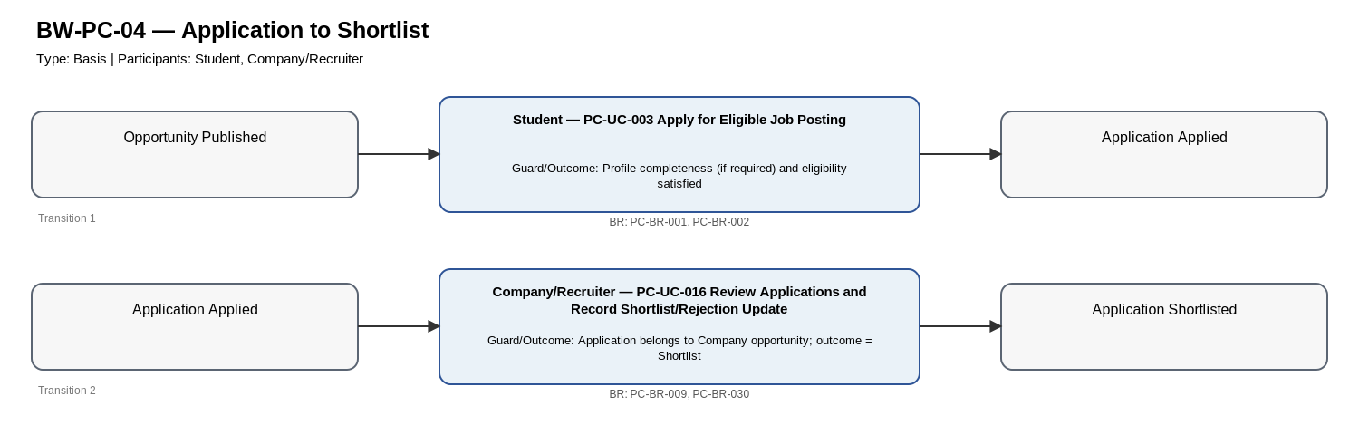
Editable source: Workflow_Diagrams/PC_Workflow_Diagrams_v1.2_SYNCHRONIZED.drawio (page BW-PC-04).

BW-PC-05: Shortlist to TPO-Coordinated Interview
Type | Basis
Purpose / Scope | One path from an applied application through Company/Recruiter shortlisting to a TPO-scheduled interview.
Trigger | An application is recorded as Applied.
Participants | Company/Recruiter, TPO
Constituent Workflows | N/A
Related Workflows | N/A
Related CFRs / key AFRs
Related UCs | PC-UC-009, PC-UC-016
Related BRs | PC-BR-009, PC-BR-011, PC-BR-012, PC-BR-030
Notes | None
Authoritative State-Transition Table
S. No. | From State | Actor | Use Case ID / Name | Guard / Outcome | Resulting State | BR Reference(s)
1 | Application Applied | Company/Recruiter | PC-UC-016 Review Applications and Record Shortlist/Rejection Update | Application belongs to Company opportunity; outcome = Shortlist | Application Shortlisted | PC-BR-009, PC-BR-030
2 | Application Shortlisted | TPO | PC-UC-009 Schedule Interviews and Track Interview Progress | Interview details complete; TPO authorized | Interview Scheduled | PC-BR-011, PC-BR-012, PC-BR-030
Corresponding workflow diagram
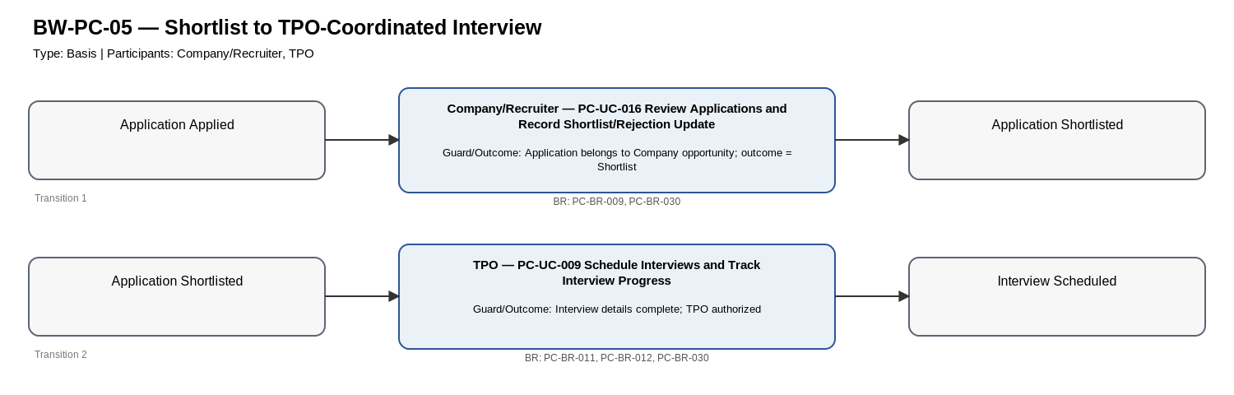
Editable source: Workflow_Diagrams/PC_Workflow_Diagrams_v1.2_SYNCHRONIZED.drawio (page BW-PC-05).

BW-PC-06: Student Application to Company-Scheduled Interview
Type | Basis
Purpose / Scope | One path from Student application through Company/Recruiter shortlisting to a Company-scheduled interview.
Trigger | Published opportunity is open to an eligible Student and Company-led scheduling is used.
Participants | Student, Company/Recruiter
Constituent Workflows | N/A
Related Workflows | N/A
Related CFRs / key AFRs
Related UCs | PC-UC-003, PC-UC-016, PC-UC-021
Related BRs | PC-BR-001, PC-BR-002, PC-BR-009, PC-BR-011, PC-BR-012, PC-BR-030
Notes | None
Authoritative State-Transition Table
S. No. | From State | Actor | Use Case ID / Name | Guard / Outcome | Resulting State | BR Reference(s)
1 | Opportunity Published | Student | PC-UC-003 Apply for Eligible Job Posting | Profile completeness (if required) and eligibility satisfied | Application Applied | PC-BR-001, PC-BR-002
2 | Application Applied | Company/Recruiter | PC-UC-016 Review Applications and Record Shortlist/Rejection Update | Application belongs to Company opportunity; outcome = Shortlist | Application Shortlisted | PC-BR-009, PC-BR-030
3 | Application Shortlisted | Company/Recruiter | PC-UC-021 Schedule Company-Led Interview | Interview details complete; Company authorized for application | Interview Scheduled | PC-BR-009, PC-BR-011, PC-BR-012, PC-BR-030
Corresponding workflow diagram
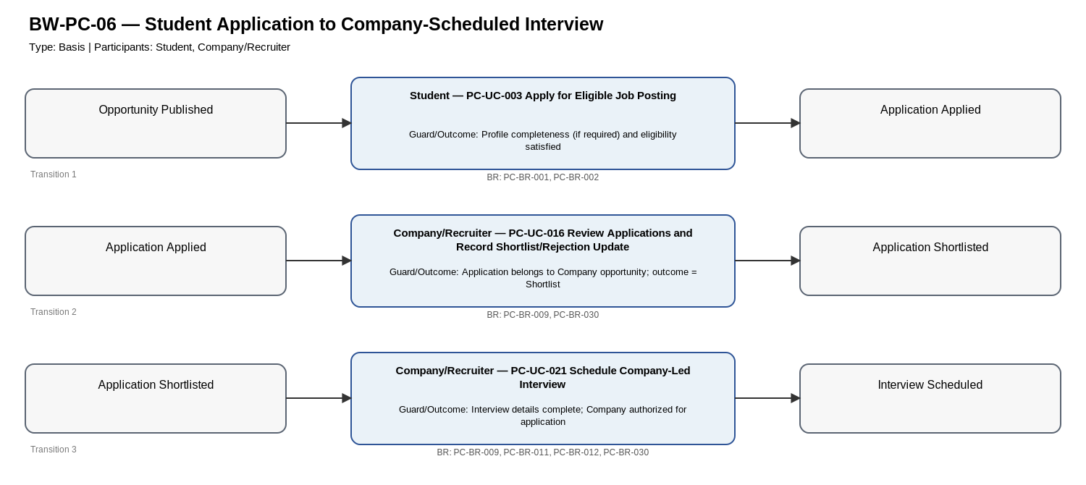
Editable source: Workflow_Diagrams/PC_Workflow_Diagrams_v1.2_SYNCHRONIZED.drawio (page BW-PC-06).

BW-PC-07: Offer Acceptance and Placement Update
Type | Basis
Purpose / Scope | One path from an active selection state through Company offer extension to Student acceptance and placement-record update.
Trigger | Company/Recruiter decides to extend an offer to a selected candidate.
Participants | Company/Recruiter, Student
Constituent Workflows | N/A
Related Workflows | N/A
Related CFRs / key AFRs
Related UCs | PC-UC-005, PC-UC-022
Related BRs | PC-BR-009, PC-BR-013, PC-BR-014, PC-BR-015, PC-BR-030
Notes | None
Authoritative State-Transition Table
S. No. | From State | Actor | Use Case ID / Name | Guard / Outcome | Resulting State | BR Reference(s)
1 | Application Shortlisted OR Interview Scheduled | Company/Recruiter | PC-UC-022 Extend Job Offer | Company authorized for application; outcome = Offer Extended | Offer Extended | PC-BR-009, PC-BR-030
2 | Offer Extended | Student | PC-UC-005 Respond to Job Offer | Response within represented deadline; outcome = Accept | Offer Accepted; Placement Record Updated | PC-BR-013, PC-BR-014, PC-BR-015
Corresponding workflow diagram
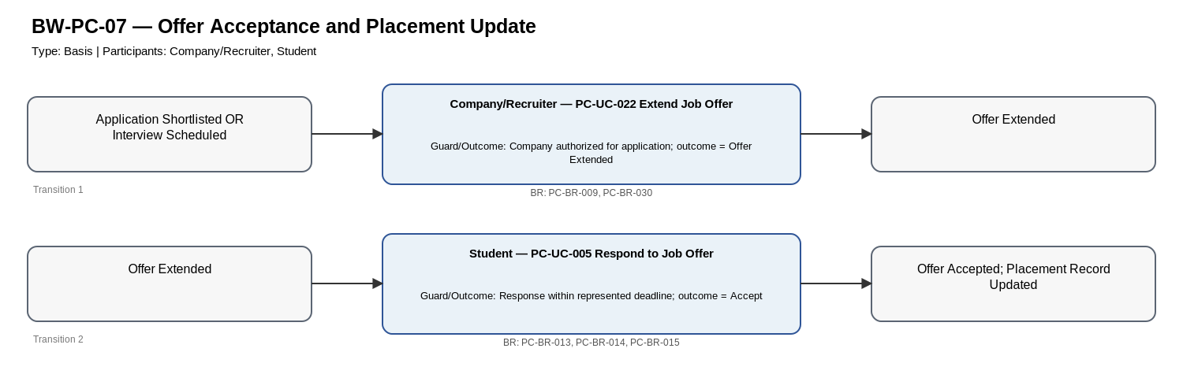
Editable source: Workflow_Diagrams/PC_Workflow_Diagrams_v1.2_SYNCHRONIZED.drawio (page BW-PC-07).

BW-PC-08: Offer Rejection
Type | Basis
Purpose / Scope | One path from an active selection state through Company offer extension to Student rejection.
Trigger | Company/Recruiter decides to extend an offer to a selected candidate.
Participants | Company/Recruiter, Student
Constituent Workflows | N/A
Related Workflows | N/A
Related CFRs / key AFRs
Related UCs | PC-UC-005, PC-UC-022
Related BRs | PC-BR-009, PC-BR-013, PC-BR-015, PC-BR-030
Notes | None
Authoritative State-Transition Table
S. No. | From State | Actor | Use Case ID / Name | Guard / Outcome | Resulting State | BR Reference(s)
1 | Application Shortlisted OR Interview Scheduled | Company/Recruiter | PC-UC-022 Extend Job Offer | Company authorized for application; outcome = Offer Extended | Offer Extended | PC-BR-009, PC-BR-030
2 | Offer Extended | Student | PC-UC-005 Respond to Job Offer | Response within represented deadline; outcome = Reject | Offer Rejected | PC-BR-013, PC-BR-015
Corresponding workflow diagram
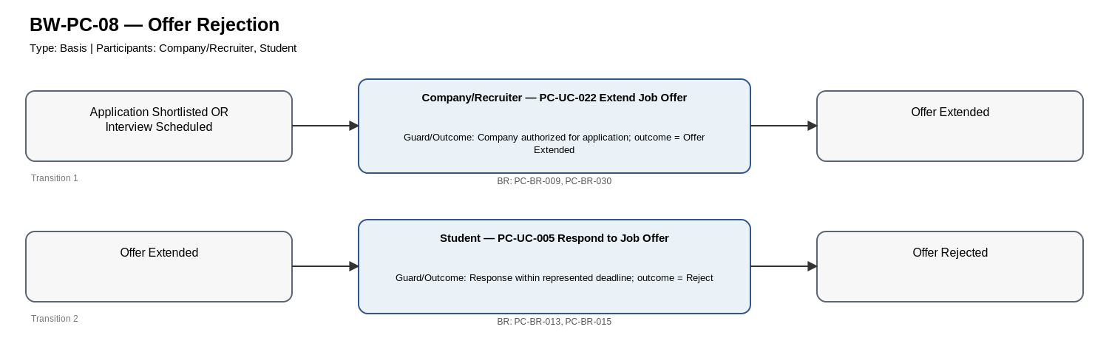
Editable source: Workflow_Diagrams/PC_Workflow_Diagrams_v1.2_SYNCHRONIZED.drawio (page BW-PC-08).

CW-PC-01: Opportunity Publication and Application Entry
Type | Composite
Purpose / Scope | Combine supported TPO-managed, direct Company publication, and Company-submit-via-TPO paths that lead to Student application.
Trigger | An opportunity is created/managed for PCMS publication.
Participants | TPO, Company/Recruiter, Student
Constituent Workflows | BW-PC-01, BW-PC-02, BW-PC-03
Related Workflows | CW-PC-04
Related CFRs / key AFRs
Related UCs | PC-UC-003, PC-UC-006, PC-UC-015
Related BRs | PC-BR-001, PC-BR-002, PC-BR-003, PC-BR-004, PC-BR-005, PC-BR-006
Notes | None
Authoritative State-Transition Table
S. No. | From State | Actor | Use Case ID / Name | Guard / Outcome | Resulting State | BR Reference(s)
1 | No published opportunity | TPO | PC-UC-006 Upload and Manage Job Postings | TPO-managed path; publish outcome | Opportunity Published | PC-BR-003, PC-BR-004, PC-BR-005
2 | No published opportunity | Company/Recruiter | PC-UC-015 Publish or Submit Company Opportunities and Define Eligibility | Direct-publication outcome | Opportunity Published | PC-BR-003, PC-BR-004, PC-BR-006
3 | No published opportunity | Company/Recruiter | PC-UC-015 Publish or Submit Company Opportunities and Define Eligibility | Submit-for-TPO outcome | Opportunity Submitted | PC-BR-003, PC-BR-004, PC-BR-006
4 | Opportunity Submitted | TPO | PC-UC-006 Upload and Manage Job Postings | TPO-managed publication outcome | Opportunity Published | PC-BR-003, PC-BR-004, PC-BR-005
5 | Opportunity Published | Student | PC-UC-003 Apply for Eligible Job Posting | Profile completeness (if required) and eligibility satisfied | Application Applied | PC-BR-001, PC-BR-002
Corresponding workflow diagram
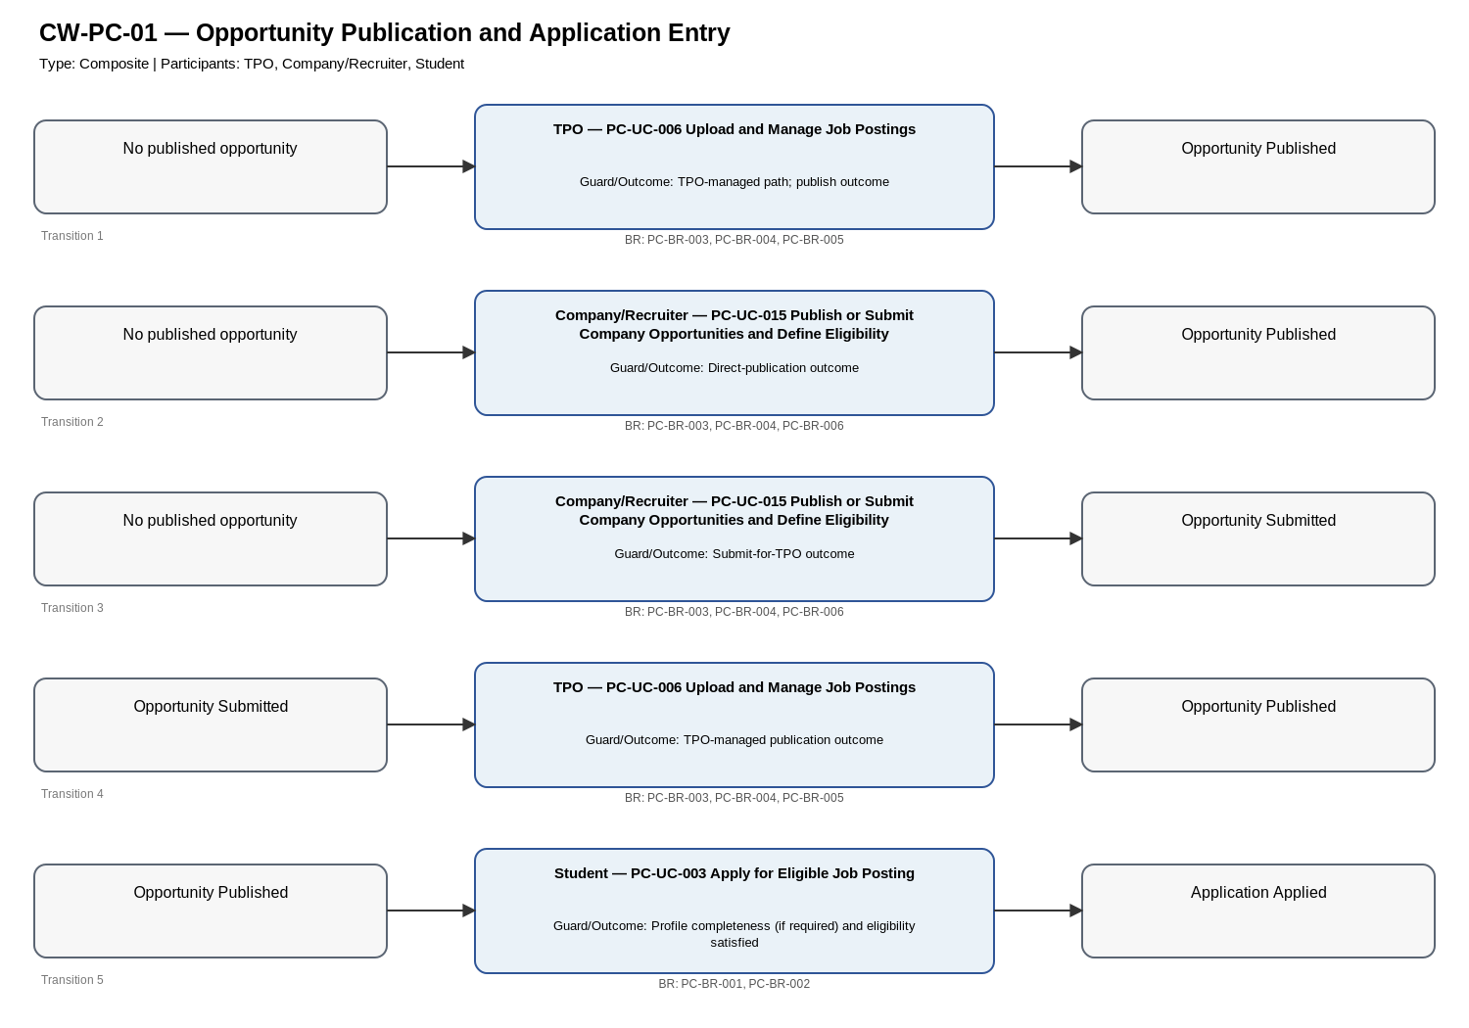
Editable source: Workflow_Diagrams/PC_Workflow_Diagrams_v1.2_SYNCHRONIZED.drawio (page CW-PC-01).

CW-PC-02: Candidate Selection and Interview Scheduling
Type | Composite
Purpose / Scope | Combine application shortlisting and the supported TPO- or Company-led interview scheduling paths.
Trigger | An application is Applied or an eligible Student applies to a published opportunity.
Participants | Student, Company/Recruiter, TPO
Constituent Workflows | BW-PC-04, BW-PC-05, BW-PC-06
Related Workflows | CW-PC-01, CW-PC-03, CW-PC-04
Related CFRs / key AFRs
Related UCs | PC-UC-003, PC-UC-009, PC-UC-016, PC-UC-021
Related BRs | PC-BR-001, PC-BR-002, PC-BR-009, PC-BR-011, PC-BR-012, PC-BR-030
Notes | None
Authoritative State-Transition Table
S. No. | From State | Actor | Use Case ID / Name | Guard / Outcome | Resulting State | BR Reference(s)
1 | Opportunity Published | Student | PC-UC-003 Apply for Eligible Job Posting | Eligibility/profile checks pass | Application Applied | PC-BR-001, PC-BR-002
2 | Application Applied | Company/Recruiter | PC-UC-016 Review Applications and Record Shortlist/Rejection Update | Outcome = Shortlist | Application Shortlisted | PC-BR-009, PC-BR-030
3 | Application Shortlisted | TPO | PC-UC-009 Schedule Interviews and Track Interview Progress | TPO-coordinated path; details complete | Interview Scheduled | PC-BR-011, PC-BR-012, PC-BR-030
4 | Application Shortlisted | Company/Recruiter | PC-UC-021 Schedule Company-Led Interview | Company-led path; details complete | Interview Scheduled | PC-BR-009, PC-BR-011, PC-BR-012, PC-BR-030
Corresponding workflow diagram
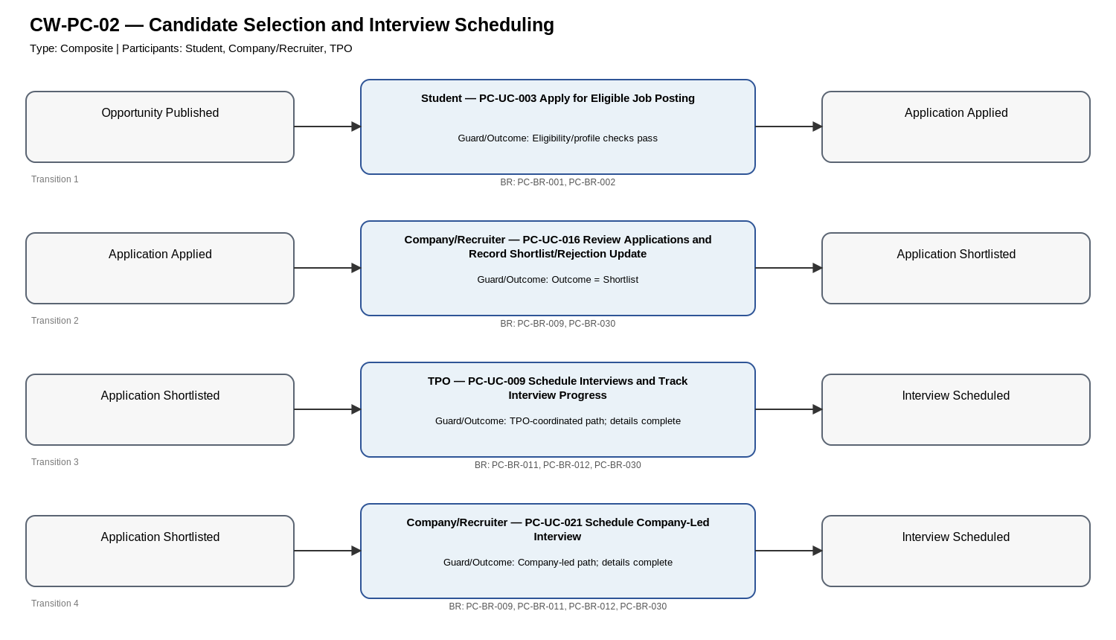
Editable source: Workflow_Diagrams/PC_Workflow_Diagrams_v1.2_SYNCHRONIZED.drawio (page CW-PC-02).

CW-PC-03: Offer and Placement Outcome
Type | Composite
Purpose / Scope | Combine offer extension with Student acceptance or rejection outcomes.
Trigger | Company/Recruiter decides to extend an offer to a selected candidate.
Participants | Company/Recruiter, Student
Constituent Workflows | BW-PC-07, BW-PC-08
Related Workflows | CW-PC-02, CW-PC-04
Related CFRs / key AFRs
Related UCs | PC-UC-005, PC-UC-022
Related BRs | PC-BR-009, PC-BR-013, PC-BR-014, PC-BR-015, PC-BR-030
Notes | None
Authoritative State-Transition Table
S. No. | From State | Actor | Use Case ID / Name | Guard / Outcome | Resulting State | BR Reference(s)
1 | Application Shortlisted OR Interview Scheduled | Company/Recruiter | PC-UC-022 Extend Job Offer | Company authorized for application | Offer Extended | PC-BR-009, PC-BR-030
2 | Offer Extended | Student | PC-UC-005 Respond to Job Offer | Within deadline; outcome = Accept | Offer Accepted; Placement Record Updated | PC-BR-013, PC-BR-014, PC-BR-015
3 | Offer Extended | Student | PC-UC-005 Respond to Job Offer | Within deadline; outcome = Reject | Offer Rejected | PC-BR-013, PC-BR-015
Corresponding workflow diagram
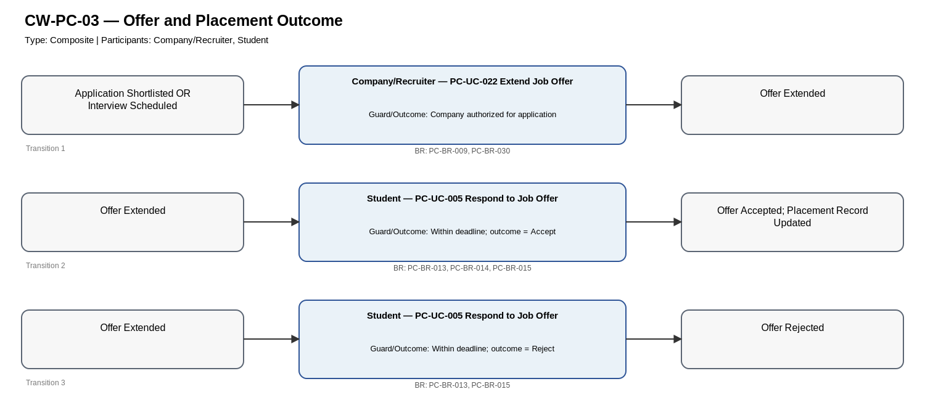
Editable source: Workflow_Diagrams/PC_Workflow_Diagrams_v1.2_SYNCHRONIZED.drawio (page CW-PC-03).

CW-PC-04: End-to-End Placement Application Lifecycle
Type | Composite
Purpose / Scope | Provide the integrated cross-actor placement application lifecycle from opportunity publication through application, shortlist/interview, offer, and final offer response without forcing unrelated company-registration or announcement behavior into the lifecycle.
Trigger | An opportunity is prepared for publication and placement processing.
Participants | TPO, Company/Recruiter, Student
Constituent Workflows | CW-PC-01, CW-PC-02, CW-PC-03
Related Workflows | N/A
Related CFRs / key AFRs
Related UCs | PC-UC-003, PC-UC-005, PC-UC-006, PC-UC-009, PC-UC-016, PC-UC-022
Related BRs | PC-BR-001, PC-BR-002, PC-BR-003, PC-BR-004, PC-BR-005, PC-BR-006, PC-BR-009, PC-BR-011, PC-BR-012, PC-BR-013, PC-BR-014, PC-BR-015, PC-BR-030
Notes | Interview is not made a mandatory prerequisite for offer extension because the baseline does not state that restriction; both Shortlisted and Interview Scheduled are explicitly represented as valid pre-states for offer extension.
Authoritative State-Transition Table
S. No. | From State | Actor | Use Case ID / Name | Guard / Outcome | Resulting State | BR Reference(s)
1 | No published opportunity | TPO or Company/Recruiter | PC-UC-006 or PC-UC-015 | Authorized publication path and required content valid | Opportunity Published | PC-BR-003, PC-BR-004, PC-BR-005, PC-BR-006
2 | Opportunity Published | Student | PC-UC-003 Apply for Eligible Job Posting | Profile completeness (if required) and eligibility satisfied | Application Applied | PC-BR-001, PC-BR-002
3 | Application Applied | Company/Recruiter | PC-UC-016 Review Applications and Record Shortlist/Rejection Update | Outcome = Shortlist | Application Shortlisted | PC-BR-009, PC-BR-030
4 | Application Shortlisted | TPO or Company/Recruiter | PC-UC-009 or PC-UC-021 | Supported interview-scheduling path; required interview details complete | Interview Scheduled | PC-BR-009, PC-BR-011, PC-BR-012, PC-BR-030
5 | Application Shortlisted OR Interview Scheduled | Company/Recruiter | PC-UC-022 Extend Job Offer | Authorized Company/Recruiter; selected candidate | Offer Extended | PC-BR-009, PC-BR-030
6 | Offer Extended | Student | PC-UC-005 Respond to Job Offer | Within deadline; outcome = Accept | Offer Accepted; Placement Record Updated | PC-BR-013, PC-BR-014, PC-BR-015
7 | Offer Extended | Student | PC-UC-005 Respond to Job Offer | Within deadline; outcome = Reject | Offer Rejected | PC-BR-013, PC-BR-015
Corresponding workflow diagram
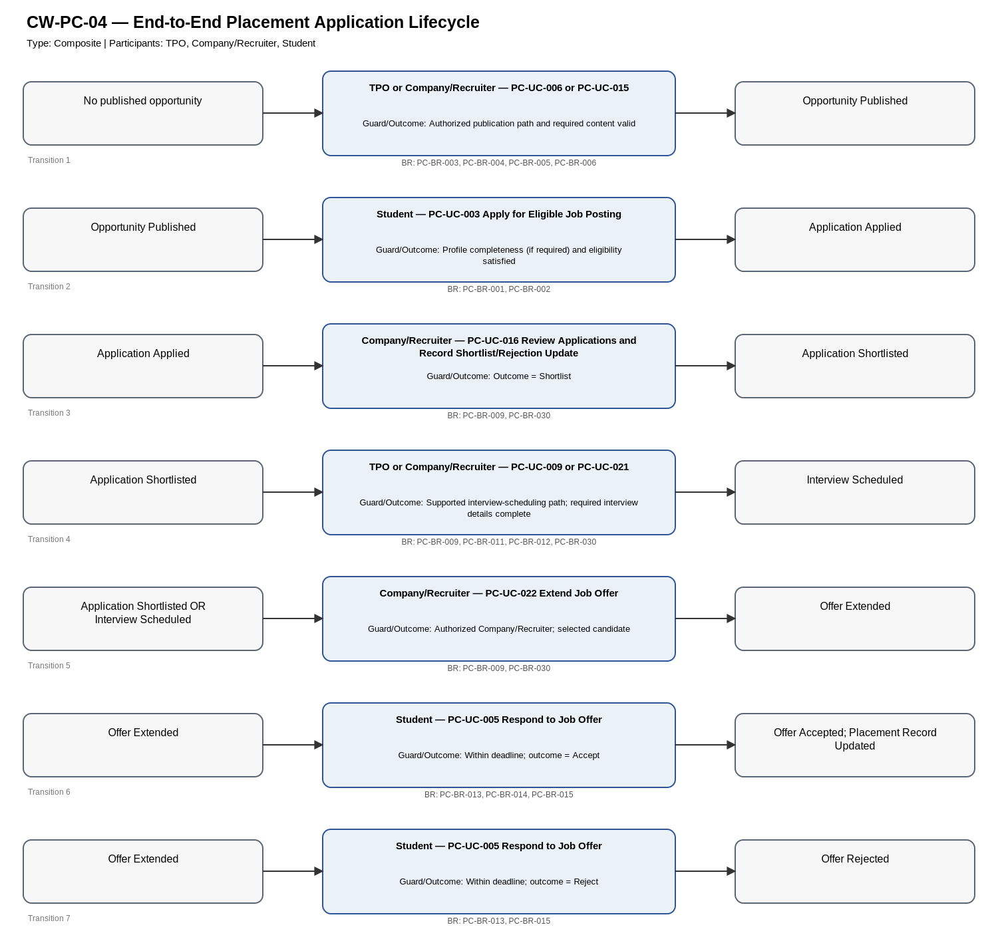
Editable source: Workflow_Diagrams/PC_Workflow_Diagrams_v1.2_SYNCHRONIZED.drawio (page CW-PC-04).

3. DIRECT_FINAL_v2 Finalization Note
No workflow state, transition, actor, guard, or outcome required semantic modification in this pass. The v1.2 editable workflow draw.io source is therefore preserved unchanged. Only workflow rationale/traceability metadata was revised to remove the superseded actor-count criterion and to reference the final CFR/AFR registry.

